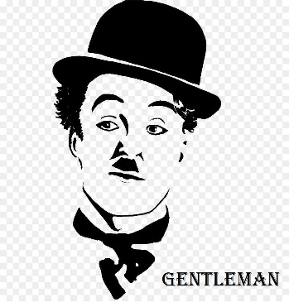

***PROJECT PLAN***

***FOR***

***Residential Communication Channel System***

***Version 1.3***

***Team 2 - GENTLEMAN***

***Revision***

|  |  |  |  |
| --- | --- | --- | --- |
| *Author* | *Version* | *Date* | *Content* |
| *Manh Truong* | ***1.1*** | *24/10/2018* | *Initiate Document* |
| *Manh Truong* | ***1.2*** | *27/10/2018* | *Update content for document* |
| *Vinh Nguyen* | ***1.3*** | *28/10/2018* | *Review and Update Document* |

Table of Contents

***1.*** ***Document Overview*** 2

***a.*** ***Purpose*** 2

***b.*** ***Audience*** 2

***2.*** ***Project Overview*** 2

***a.*** ***Objective*** 2

***b.*** ***Outcomes*** 3

***c.*** ***Deliverable*** 3

***d.*** ***Constraint*** 4

***3.*** ***Project Development*** 4

***a.*** ***Development Architecture & Design*** 4

***b.*** ***Development Methodology*** 4

***c.*** ***Role & Responsibility*** 5

***4.*** ***Project Master & Detail Plan*** 6

***5.*** ***Project Communication Management*** 6

***6.*** ***Project Configuration Management*** 6

***7.*** ***Project Change Management*** 6

***8.*** ***Project Risk Management*** 6

***9.*** ***Reference*** 7

1. ***Document Overview***
   1. ***Purpose***
      * The document provides an overview for the demonstration of project management and development activities for the Residential Communication Channel of GENTLEMAN TEAM.
   2. ***Audience***

|  |  |  |
| --- | --- | --- |
| **Intended Audience** | **Name** | **Reading Suggestions** |
| GENTLEMAN – Team Member | * Manh Truong * Quan Ngo * Hao Vo * Lam To * An Pham | Review Document |
| Mentor | * Mr.Quoc | Review Document |
| Project Manager | * Vinh Nguyen | Initiate and Document Specification |
| Customer | * Mr.Dat | Review Document |

1. ***Project Overview***
   1. ***Objective***
      * The objectives of project are:
        + To developed an application to assist the Management Board and Residents in interacting with the community with the following features:
          - Assist the building management board to collect feedback from residents about issues that need to be addressed. From that, do the plan of implementation and monitor the implementation.
          - Provides a channel for exchanging information between the management and the building management and has a process for monitoring the operation of the building management.
          - Provide information channels for residents with the form of the integrated Chat room search information in the direction of AI is able to intelligently identify the keyword

* Complete the system on two platform : Web and Mobile
  1. ***Outcomes***
     + Artifacts that relating to project management and development like Section c. Deliverable below.
     + A Residential Communication Channels System will meet the all requirement and objectives above.
  2. ***Deliverable***

|  |  |  |
| --- | --- | --- |
| Deliverable Title | Artifacts Name | Description |
| Project Planning | ***RCC_PM_ProjectPlan*** | Provides an overview of the project and summarizes key elements of the project that the project team must pay attention to and implement. |
| Project Master & Detail Plan | ***RCC_PM_Master&DetailPlan*** | The Master Plan will show the overall progress of project.  The Detail Plan will show the detail progress of project and describes tasks of each team member or team takes and the time to do the work |
| Architecture and Design | **RCC_AD_ArchitectureDriver**  **RCC_AD_ArchitectureDesign** | The document consists of two files: The Architecture Driver describes the initial requirements for the system and the quality attributes. Architecture Design represents the architectural drawings of the product to demonstrate the quality attributes of the system will develop and meet the needs of customers |
| UseCase | **RCC_RE_UseCase** | The document describe the business activity flow of each function by graphics the interaction between actor and system. This document must be validate by customer |
| Software Requirement Specification | **RCC_RE_SRS** | The document will describe all feature and user requirement, functional requirement of system. This document must be validate by customer |
| Test Case | **RCC_TE_TestCases** | Includes documentation that tests product use cases to find defects or defects in the product |
| Test Report | **RCC_TE_TestReport** | The document report status of the project, the number of test cases passed, the number of test cases failed to demonstrate the quality of the product. |
| Guideline | **RCC_DE_Guideline** | User guide or how to access and use the product |
| Project Product | **RCC_DE_Product** | The product is made by the project team |

* 1. ***Constraint***
     + **Technical:** 
       - Web: System run on popular applications (Firefox, IE, Chrome)
       - Mobile: System run on two OS ( iOS and Android)
       - Database: Integration with the database of the RealEstateBroker project has been develop previously.
     + **Business:**
       - The web and mobile interface must support multiple languages ​​(Vietnamese, English) and the default language is Vietnamese***.***
       - Duration of project must be within 30 weeks
     + **Process:**
       - Team must use Iterative Approach to develop this project

1. ***Project Development***
   1. ***Development Architecture & Design***
   2. ***Development Methodology***
      * Acording to the process constraint, the team use Iterative Approach method to develop and manage project

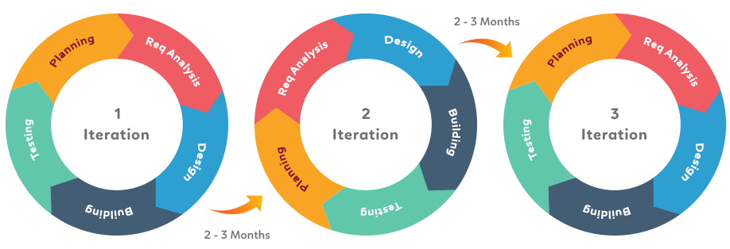

* + - The phases of each Iteration:
      * Planning: At the first phase of all iteration, the Project Manager ( Vinh Nguyen ) will prepare the plan to manage the progress of project, all thing to work in the current iteration and inform each member about their tasks by using Master Plan and Detail Plan.
      * Req Analysis: The Gentleman Team will meet the customer at each week to gathering new requirement and validate requirements has been gathered at last week.
      * Design: In this phase, Project Manager ( Vinh Nguyen ) will meeting with team to analyze and define Architect Driver by gather High – Level Requirement, Quality Requirement for RCC System. Then design the views by provide solution to meet the Quality and High – Level requirement and graphics on three views ( Dynamic, Static, Allocation ). After Architecture Design has been satisfied, the Gentleman Team will start detail designing for each function as ( design Sequence Diagram, Class Diagram,.. ) to provide the detail design form for helping team easy to coding without doing wrong. Technical Analysist ( Manh Truong ) and Data Analysist ( Quan Ngo ) has been involve to this phase and responsible for suggest solution to deal with Quality and High – Level Requirement.
      * Building: After completing the design phase, the Gentleman Team will start at the product development stage based on the detail design form at Design Phase. At this phase, all member of Gentleman team will join to develop product. Mobile Developer ( Hau Vo) and ASP.NET Developer ( Lam To ) will responsible for leading and guiding others of team to developing the product correctly in two platform ( Web and Mobile ).
      * Testing: Test plan and test cases will be defined at this stage, Test Lead ( An Pham ) will prepare Test Plan and others of team will develop Test Case ( used for Functional Test and Unit Test) to detect and remove Defect. In addition, other types of testing will be developed to help increase the quality of the product as: Automation Test, System Test, Integration Test,….
    - Stages will be implemented continuously until a part of the increment product is produced that can be handed over to the customer.
    - After completing the increment of the product, the Gentleman Team will step through the next iteration and repeat the same steps as the first one. Until the product is completed and meets all Functional and non-functional requirements. Iteration loops will end and the product will be put into maintenance phase.
  1. ***Role & Responsibility***

|  |  |  |
| --- | --- | --- |
| **Name** | **Role** | **Responsibility** |
| Vinh Nguyen | Project Manager, Team Leader | Provide project progress reports periodically for customer and manage the activities of team, breakdown task and assign to team members. Keep the project under control and make the team always ready to working hard. Set time to the team can meet mentor and customer. |
| Manh Truong | Team Advisor, Technical Analysist | Suggest ideas that help improve the way team work and propose to solve problems on technical work. |
| Quan Ngo | Data Analysist, Developer | Responsible for analyze data, model, data structure and make the data flow of the project align with the functional requirements |
| Hau Vo | Mobile Developer | Research and develop product in Mobile platform, instructing the project team what has worked and solved some of the difficult problems in the mobile platform |
| Lam To | ASP.NET Developer | Research and develop product in ASP.NET MVC platform, instructing the project team what has worked and solved some of the difficult problems in the .Net platform |
| An Pham | Test Lead, Team Recorder | Responsible for record all meeting minute include: team meeting, customer meeting, mentor meeting. Plan for test and manage test plan to improve quality of product. |
| Mr. Quoc | Mentor | Lead the project team and propose ideas so that the project team can properly develop and manage the project. |
| Mr.Dat | Customer | Spend the time to provide and clarify requirements. Be specific and precise about requirements. Promptly communicate changes to requirements. Set requirement priorities. |

1. ***Project Master & Detail Plan***

*Please refer to RCC_PM_MasterPlan&DetailPlan.xlsx*

1. ***Project Communication Management***

*Please refer to RCC_PM_CommunicationManagementPlan.docx*

1. ***Project Configuration Management***

*Please refer to RCC_PM_ConfigurationManagement.docx*

1. ***Project Change Management***

*Please refer to RCC_PM_ChangeManagement.docx*

*Please refer to RCC_PM_ChangeManagementLog.xlsx*

1. ***Project Risk Management***

*Please refer to RCC_PM_RiskManagementPlan.docx*

*Please refer to RCC_PM_RiskManagementLog.xlsx*

1. ***Reference***

RCC_PM_MasterPlan&DetailPlan.xlsx

RCC_PM_CommunicationManagementPlan_ver1.3.docx

RCC_PM_ConfigurationManagement_ver1.3.docx

RCC_PM_ChangeManagement_ver1.3.docx

RCC_PM_ChangeManagementLog.xlsx

RCC_PM_RiskManagementPlan_ver1.3.docx

RCC_PM_RiskManagementLog.xlsx